 VINOD SIR’S GROUP TUTION

MARKS: 25 IX-MATHS-II TIME: 1 Hr. 30 Mins.

Q. 1: Fill in the box by solving the following sums: [2]
1. 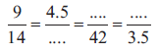

Q. 2: Compare the following pairs of ratios. [4]
1. 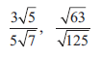 2. 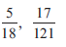

Q. 3: The ratio of monthly income to the savings in a family is 5 : 4 If the savings be Rs. 9000, find the income and the expenses. [2]

Q. 4: (x + 3) : (x + 11) = (x - 2) : (x + 1) then find the value of x. [2]

Q. 5: 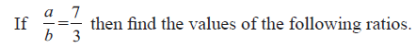 [2]
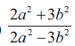
Q. 6: 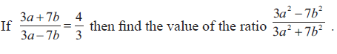 [2]

Q. 7: [4]
1. 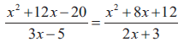 2. 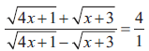

Q 8: 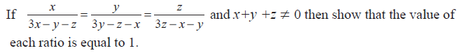
[2]
Q 9: 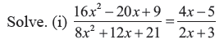 [3]

Q. 10: Which number should be subtracted from 12, 16 and 21 so that resultant numbers are in continued proportion? [2]

